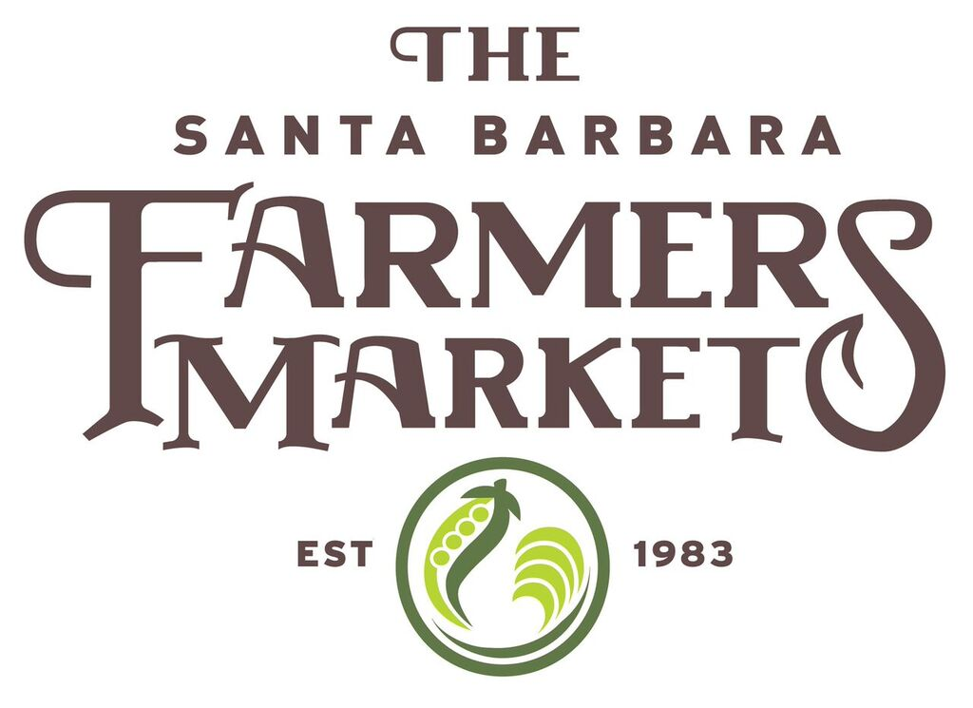
SBCFMA Dairy Application
Note: Those interested in selling cheese, milk, or other dairy products at our markets must own or lease the land where the animals reside that are sourced for your dairy products. You may include insert pages if you need additional space to complete this form.

Name of Farm/Ranch/Business: _________________________________________________

Name of Applicant: ___________________________________________________________
Must be the individual that personally owns, or has a legal lease agreement, for the land where the animals reside.

Mailing Address: _____________________________________________________________
__________________________________________________________________________

Contact Person: ____________________________________________________________

Phone Number :(_______)___________________________________________________

Email Address: ______________________________________________________________

Total acreage of site(s) where animals reside: ______________________________________
_____________________________________________________________________________

State the head count for animals of which you are requesting to produce your dairy products from for sale at farmers market that currently reside on the property in which you personally lease or own: Cattle ____________ Goat __________Sheep ____________

State the approximate age at which you acquire your animals:
Cattle ______________ Goats ______________ Sheep ________________
*You can state “born under ownership” or provide an approximate age.

State the approximate age range of the animals from which you produce milk:
Cattle ________________ Goats ________________ Sheep__________________
*Example; 3-8 yrs

Physical address where your animals are born: ___________________________________
____________________________________________________________________________

Physical address where your animals are milked: __________________________________
_____________________________________________________________________________

State the feed provided to animals under your care: ________________________________
_____________________________________________________________________________

Name of Health Dept. approved facility where your dairy products are processed: _____________________________________________________________________________
Physical Address: _____________________________________________________________
_____________________________________________________________________________
Contact individual at creamery/processing facility: _____________________________________________________________________________
Contact phone number at creamery/processing facility: _____________________________________________________________________________

List all dairy products you are requesting to sell at SBCFMA farmers markets (include specific types of cheese, milk, butter, yogurt, pasteurized or raw, etc.) : ________________
_________________________________________________________________________
________________________________________________________________________
_________________________________________________________________________

How will your products be transported and stored at farmers market: _____________________________________________________________________________________________________________________________________________________
________________________________________________________________________
Do you have a cold storage facility? : YES___________ NO______________
If yes, please provide location name, address, and contact number: ___________________
__________________________________________________________________________________________________________________________________________________________

List all farmers markets in which you currently participate: ________________________
____________________________________________________________________________________________________________________________________________________________________________________________________________________________________________________________________________________________________________________________________________________________________________________________________________________________________________________________________________
*This also includes farmers markets not associated with the SBCFMA.

Any additional information about your operation: _________________________________
____________________________________________________________________________________________________________________________________________________________________________________________________________________________________________________________________________________________________________________

List of required documents that must accompany this renewal application:
Please provide the following documents below along with this application, if applicable. Additional documentation may be required.
- Bill of sale(s) for all animals you have purchased that are being milked at your facility/dairy
and sold at these farmers’ markets (you may block out cost amounts). ______
- Milk Handlers License ______
- Copy of lease agreement where animals reside (cost amounts can be blocked out)
- Copy of your USDA approved processing facility health permit ______
- Grade A permit for milk production ______
- Tuberculosis test record ______
- State of California Dairy producer/handler/processor application and registration ______
- Copy of Product Liability Insurance ______
- Copy or photo of the packaging labels for your various products ______

Members are required to have all current and valid paperwork on file with the SBCFMA. When documents expire throughout the year, you must provide the SBCFMA with current copies. Any changes to your operation, including but not limited to; change in business structure, designation of your active participant, change in organic status, amended certified producers certificates, change in Health department approved facility location, change in product liability status/provider, or any other changes to the documents listed above, must be submitted to the SBCFMA before sales may resume at any given market location.

I hereby state that all the information provided on this SBCFMA Farmer Application is accurate and true.

Name of Applicant (Print Name and Sign):_____________________________________________Date: _____________

To submit Application;
- Mail to 232 Anacapa St. STE 1A, Santa Barbara CA 93101 OR
- Email to Sam@sbfarmersmarket.org OR
- Drop off at our market information booth at any of our SBCFMA farmers’ market locations

232 Anacapa St. Suite 1A, Santa Barbara CA 93101 sbcfma@rain.org 805-962-5354

